BIOLOGY
UNIT 3
2022

Name:

Teacher:

Time allowed for this paper
Reading time before commencing work: ten minutes
Working time: three hours

Materials required/recommended for this paper
To be provided by the supervisor
This Question/Answer booklet
Multiple-choice answer sheet

To be provided by the candidate
Standard items: pens (blue/black preferred), pencils (including coloured), sharpener, correction fluid/tape, eraser, ruler, highlighters

Special items: non-programmable calculators approved for use in this examination

Important note to candidates
No other items may be taken into the examination room. It is your responsibility to ensure that
you do not have any unauthorised material. If you have any unauthorised material with you, hand
it to the supervisor before reading any further.

Structure of this paper

Section | Number of questions available | Number of questions to be answered | Suggested working time (minutes) | Marks available | Percentage of examination
Section One  Multiple-choice | 30 | 30 | 40 | 30 | 30
Section Two  Short answer | 5 | 5 | 90 | 100 | 50
Section Three  Extended answer  Part A | 2 | 1 | 50 | 40 | 20
Part B | 2 | 1
 |  |  |  | Total | 100
Instructions to candidates

1. The rules for the conduct of the Western Australian external examinations are detailed In the Year 12 Information Handbook 2022. Sitting this examination implies that you agree to abide by these rules.

2. Write your answers in this Question/Answer booklet preferably using a blue/black pen. Do not use erasable or gel pens.

3. Answer the questions according to the following instructions.

Section One: Answer all questions on the separate Multiple-choice answer sheet provided. For each question, shade the box to indicate your answer. Use only a blue or black pen to shade the boxes. Do not use erasable or gel pens. If you make a mistake, place a cross through that square, then shade your new answer. Do not erase or use correction fluid/tape. Marks will not be deducted for incorrect answers. No marks will be given if more than one answer is completed for any question.

Section Two: Write your answers in this Question/Answer booklet. Wherever possible, confine your answers to the line spaces provided.

Section Three: Consists of two parts each with two questions. You must answer one question from each part. Tick the box next to the question you are answering. Write your answers in this Question/Answer booklet.

4. You must be careful to confine your answers to the specific questions asked and to follow any instructions that are specific to a particular question.

5. Supplementary pages for planning/continuing your answers to questions are provided at the end of this Question/Answer booklet. If you use these pages to continue an answer, indicate at the original answer where the answer is continued, i.e., give the page number.
Section One: Multiple-choice 30% (30 Marks)

This section has 30 questions. Answer all questions on the separate Multiple-choice answer sheet provided. For each question, shade a box to indicate your answer. Use only a blue or black pen to shade the boxes. Do not use erasable or gel pens. If you make a mistake, place a cross through that square, then shade your new answer. Do not erase or use correction fluid/tape. Marks will not be deducted for incorrect answers. No marks will be given if more than one answer is completed for any question.

Suggested working time: 40 minutes.

1. The smallest part of DNA that can be mutated is a

(a) gene.
(b) chromosome.
(c) codon.
(d) nucleotide.

2. Which of the following, correctly states the function of the four different enzymes involved in DNA replication.

 | Proteins
 | Helicase | DNA ligase | RNA primase | DNA polymerase
(a) | joins sections of DNA to create an unbroken sugar phosphate backbone | joins RNA nucleotides to form primers that are complementarity to the DNA strand | adds DNA nucleotides to the 3’ end of the newly synthesised DNA strand | Unwinds the DNA double helix resulting in a replication fork
(b) | adds DNA nucleotides to the 3’ end of the newly synthesised DNA strand | Unwinds the DNA double helix resulting in a replication fork | joins sections of DNA to create an unbroken sugar phosphate backbone | joins RNA nucleotides to form primers that are complementarity to the DNA strand
(c) | unwinds the DNA double helix resulting in a replication fork | joins sections of DNA to create an unbroken sugar phosphate backbone | joins RNA nucleotides to form primers that are complementarity to the DNA strand | adds DNA nucleotides to the 3’ end of the newly synthesised DNA strand
(d) | joins RNA nucleotides to form primers that are complementarity to the DNA strand | adds DNA nucleotides to the 3’ end of the newly synthesised DNA strand | Unwinds the DNA double helix resulting in a replication fork | joins sections of DNA to create an unbroken sugar phosphate backbone

Use the following statements about RNA to answer question 3.

1 | mRNA copies DNA in the ribosomes and carries the information to the nucleus.
2 | mRNA can form base pairs.
3 | tRNA is double stranded.
4 | tRNA anticodon codes for a specific amino acid.
5 | RNA contains nucleotides
6 | RNA contains nitrogenous bases include adenine, cytosine, uracil, and guanine.

3. Which statements about mRNA are correct?

(a) 1, 2, 3, 5 and 6
(b) 1, 3, 4 and 5
(c) 2, 5 and 6
(d) 2, 4, 5 and 6

4. The cells that result from meiosis are

(a) genetically identical diploid cells.
(b) genetically different haploid cells.
(c) genetically identical haploid cells.
(d) genetically different diploid cells.

5. The molecular clock is a term for a process that

(a) looks at the rate of mutation on biomolecules to calculate when a group of organisms diverged.
(b) compares many biomolecules across different species to see the relatedness of organisms.
(c) predicts the mutation rate of organisms and how current species will diverge.
(d) uses organic molecules of a species to inform scientists about the history of the
species.

Use the following information to answer questions 6. and 7

The pedigree below, shows the inheritance of an autosomal recessive characteristic (bb).

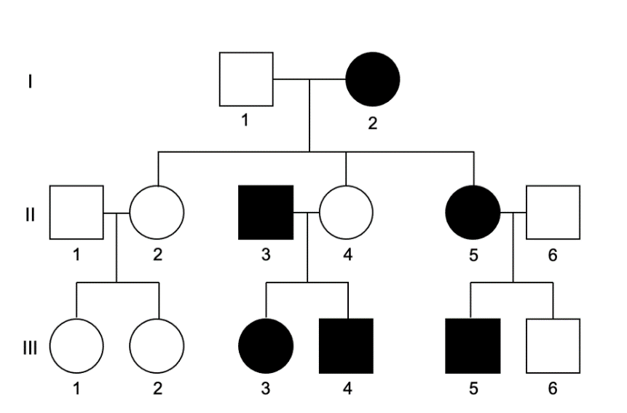

6. The genotype of individual (III, 2) is

(a) BB or Bb.
(b) BB.
(c) Bb.
(d) bb.

7. The probability that individuals (II, 5) and (II, 6) will have an affected child is

(a) 25 %
(b) 50 %
(c) 75 %
(d) 100 %

One gene was analysed to determine the number of bases in that gene. The table below shows the results of the analysis for each strand of DNA (A and B) in the gene. Use the information to answer question 8.

 | A | C | G | T
Strand A | 35 |  | 26
Strand B | 48 |  | 92

8. The number of amino acids coded for by the gene is

(a) 21.
(b) 67.
(c) 134.
(d) 201.

Different scientists have studied the evolutionary relatedness of big cats. Two different scientists (A and B) have produced different phylogenetic trees for big cats. Use this information to answer question 9 and 10.
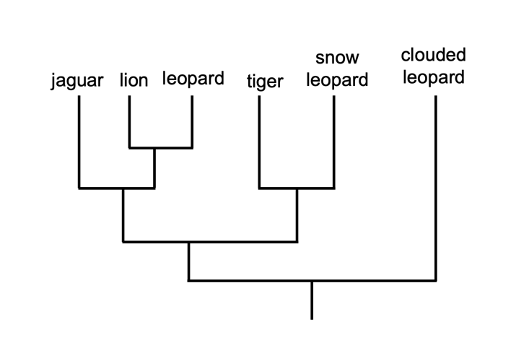
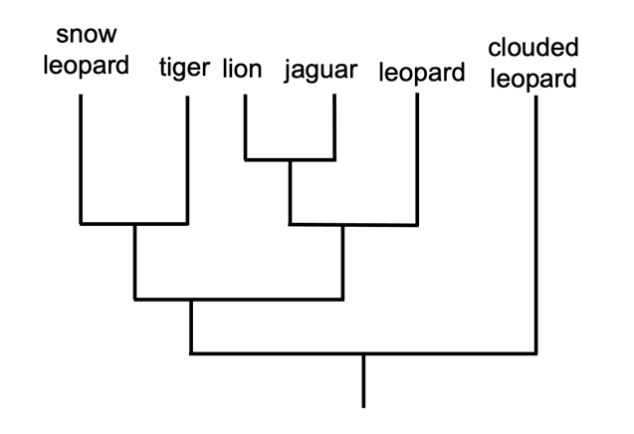

B
A

9. Both phylogenetic tree A and phylogenetic tree B show that

(a) lions and leopards have an immediate common ancestor.
(b) clouded leopards do not have a common ancestor with any other big cats.
(c) lions, jaguars and leopards have an immediate common ancestor
(d) tigers and jaguars are the most closely related big cats.

Use the following statements about the phylogenetic trees above to answer question 10.

1 | The lion and jaguar are the most closely related species
2 | The clouded leopard is most distantly related to all other cat species
3 | The snow leopard and tiger are closely related species
4 | The tiger and lion share a more distant common relative than the snow leopard and the lion
5 | The jaguar is more closely related to the leopard than it is the tiger
6 | The lion and the clouded leopard do not share a common ancestor

10. Which statements are supported by both phylogenetic trees?

(a) 1, 2, 3, 5 and 6
(b) 1, 3, 4 and 5
(c) 2, 5 and 6
(d) 2, 3 and 5

11. The phase of the cell cycle in which DNA is replicated is called

(a) anaphase.
(b) telophase.
(c) synthesis phase.
(d) interphase.

12. Genetic variation can be due to

I meiosis
II adaptations
III sexual reproduction
IV mutations
V mitosis

(a) I, II and IV only.
(b) II, III and V only.
(c) I, IV and V only.
(d) I, III and IV only.

Use the following information to answer question 13.

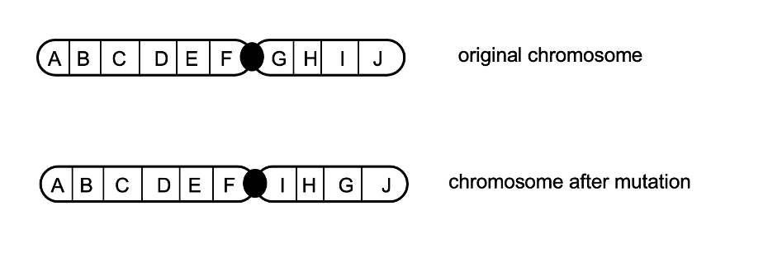

13. The mutation shown is

(a) a translocation.
(b) a deletion.
(c) an inversion.
(d) a duplication.

The image below relates to question 14.
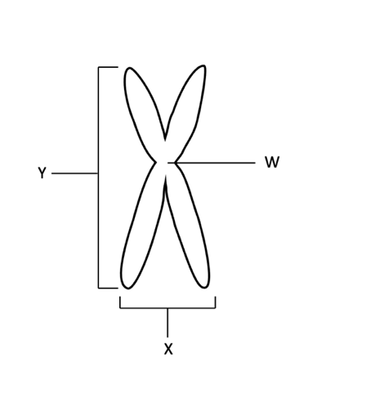

14. The correct labels for the structures shown are

 | W | X | Y
(a) | centriole | chromatid | chromosome
(b) | centromere | chromosome | chromatid
(c) | centromere | centriole | telomere
(d) | chromatid | chromosome | centriole

Questions 15 and 16 relate to the information below.
Stage A
The DNA making up a human gene is isolated using restriction enzymes.
Stage C
The DNA of a bacterial plasmid is cut open using restriction enzymes.

Stage E
The DNA of the human gene is inserted into the bacterial plasmid DNA.

Stage D
The plasmid containing the human gene is put back into a bacterium.

Stage B
The bacteria with the human gene divide and make the human protein.

15. The correct order for the stages in the process shown is

(a) D, B, C, A, E
(b) A, C, E, D, B
(c) B, D, A, C, E
(d) E, A, D, B, C

16. Stage D involves a process called:

(a) splicing
(b) ligation
(c) transformation
(d) culturing

The diagram below refers to questions 17 and 18.
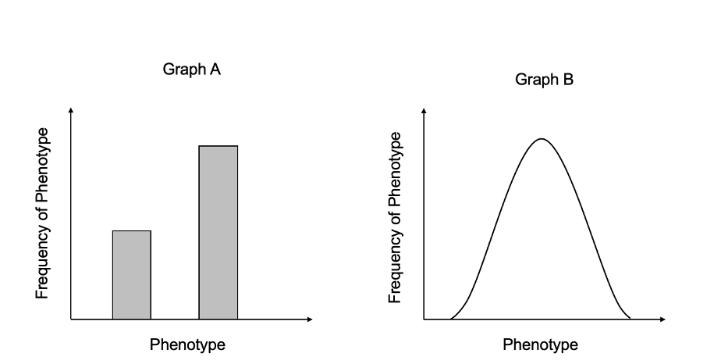

17. Graph A shows a trait which is

(a) polygenic and has a discontinuous. phenotype.
(b) monogenic and has a discontinuous phenotype.
(c) polygenic and has a continuous phenotype.
(d) monogenic and has a continuous phenotype.

18. Which of the follow traits could be represented by graph B?

- chimpanzee height, human skin colour, human intelligence
- chimpanzee height, human skin colour, human blood group
(c) coat colour in cows, human intelligence, pea colour
(d) attachment of earlobes in humans, pea colour, human blood groups
19. When both alleles are fully expressed in the phenotype of the offspring the characteristic is known as

(a) pseudo-dominance.
(b) incomplete dominance
(c) co-dominance.
(d) non-recessive inheritance.

20. Different species are more likely to have had a more recent common ancestor if they have

- a larger number of similar amino acids for the same protein.
- many similar functions but different structures.
(c) are found in the same geographic region.
(d) many similar functions and live in similar environments.

21. Peacocks (male) fan out their tail feathers and flutter them in an attempt to attract a mate. The peacock is

(a) is only trying to attract a peahen (female).
(b) competing with other peacocks whilst trying to attract a peahen.
(c) competing with peahens to attract a peacock.
(d) is only competing with peacocks.

22. Genetically engineered salmon is being successfully sold in Canada after approval by authorities. Genes from another species of salmon and an ocean pout have been inserted into the GE salmon’s DNA. These genes both accelerate and maintain the growth rate of the salmon until they are harvested. The engineered salmon are sterile, grow twice as fast as regular salmon and consume 25% less food.

While environmental activists still oppose the sale of the salmon, genetically modified food like this may be beneficial to the world’s growing populations because it:

(a) provides a more sustainable method of obtaining fish protein.
(b) contains elevated levels of growth hormone that could help malnourished children in impoverished communities.
(c) enhances the economic growth of the genetic engineering company.
(d) could pass its newly altered genome onto the ‘wild’ form of the species, increasing the quality and quantity of natural salmon populations.

Use the information below to answer questions 23 and 24.

The diagram below shows a segment of DNA with a total length of 3200 base pairs. The arrows indicate the position at which restriction enzymes cleave the DNA molecule.

G

F

E

DNA segment
280
900
1600
length (base pairs)
3200

23. If restriction enzyme G became denatured during the experiment, the length of the resulting base-pair segments would be

(a) 280, 620, 700 and 1600.
(b) 900 and 2300.
(c) 1600 and 1600.
(d) 280, 620 and 2300.

24. Which of the following ‘gels’ correctly reflects the action of restriction enzyme F?

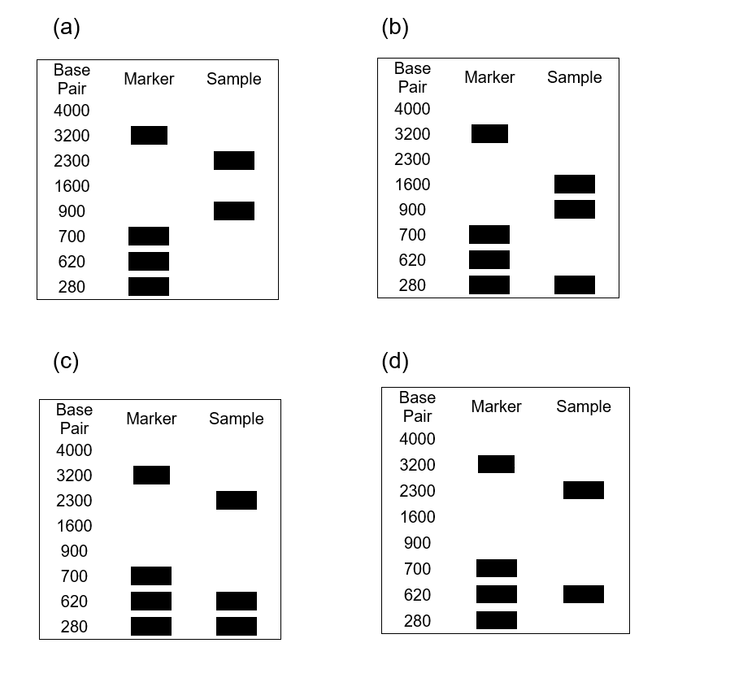

Phasmids commonly known as stick insects need to moult (shed) their exoskeleton in order to keep growing. Phasmids kept in captivity need to be regular misted with water, or they will not shed their entire exoskeleton. A biologist measured the length of the phasmids, the height of the enclosure, the number of times a day the enclosures were misted and the number of successful moults for four types of phasmids. The results are shown recorded over several in the table below. Use this data to answer question 25.

Phasmid Type | Length of Phasmid (cm) | Number of times enclosure is misted per day | Height of Enclosure | Number of successful moults
Crowned | 12 | 4 | 38 | 5
Spiny Leaf | 15 | 5 | 20 | 2
Giant | 58 | 5 | 175 | 5
Garden | 20 | 4 | 35 | 1

25. Which of the following would be a suitable conclusion for the investigation conducted?

(a) Phasmids will only moult successfully when they are misted more than four times a day.
(b) Successful moults for phasmids require the enclosure to be at least three times the length of the phasmid.
(c) The shorter the length of the phasmid the less times the phasmid moults.
(d) Phasmids moult successfully in any environmental conditions.

26. Prokaryotes reproduce by

- binary fission.
- DNA replication.
(b) mitosis.
(c) meiosis.

27. In an experiment a control group

(a) is used to compare the experimental groups results to, to see the effect of the dependent variable.
(b) is used to test the procedure and ensure the experiment will result in valid data.
(c) is used to test the procedure and ensure the experiment will result in reliable
data.
(d) is used to compare the experimental groups results to, to see the effect of the independent variable.

28. The first lifeforms on earth were

(a) eukaryotes, multicellular and aquatic.
(b) simple, single celled and terrestrial.
(c) prokaryotes, unicellular and aquatic.
(d) simple, multicellular and terrestrial.

29. Which of the following is an example of a scientific observation?

(a) Echidnas enjoy the act of mating.
(b) Echidnas spines are long hollow tubes.
(c) Echidnas offspring are known as puggles.
(d) The longer the echidnas tongue the more termites the echidna catches.

30. Which of the following is true of macroevolution?

(a) The rate of evolutionary change is constant.
(b) Changes occur over long periods of geological time.
(c) Macroevolution only occurs in response to geological isolation.
(d) The introduction of new alleles into a population drives macroevolution.

End of Section One

Section Two: Short answer 50% (100 Marks)

This section has five questions. Answer all questions. Write your answers in the spaces provided.

Supplementary pages for planning/continuing your answers to questions are provided at the end of this Question/Answer booklet. If you use these pages to continue an answer, indicate at the original answer where the answer is continued, i.e. give the page number.

Suggested working time: 90 minutes.

Question 31 (21 marks)

Shown below is a 2-dimensial model of DNA.

(a) On the diagram above, label the following

- a nucleotide (1 mark)
- a hydrogen bond (1 mark)
- the sugar-phosphate backbone (1 mark)

DNA is the most important molecule in biology. Correct base pairing is essential for DNA to replicate correctly.

(b) Explain how incorrect base pairing in DNA synthesis would lead to the daughter DNA molecules not being identical to the parent DNA molecule. (3 marks)

________________________________________________________________________
________________________________________________________________________
________________________________________________________________________
________________________________________________________________________
________________________________________________________________________
________________________________________________________________________

Base analogues are molecules that can replace the normal DNA bases during DNA replication. These analogues can be used in the treatment of viral infections by inhibiting the complete replication of the viral DNA. The analogues have a modified base that stops other nucleotides bonding to it, thus ceasing DNA replication. The drug Acyclovir is used to treat herpes (a viral infection) in humans. Acyclovir contains a base analogue for guanine.

(c) Name a biotechnology technique that uses base analogues. (1 mark)

________________________________________________________________________

(d) Which molecule used in this biotechnology technique (named in part (c)) contains a base analogue? (1 mark)

________________________________________________________________________

One kilo base pair (kbp) of DNA has a length of 0.00035 mm. The herpes virus DNA is 152 kbp in length.

(e) Calculate the length of the herpes DNA. (1 mark)

________________________________________________________________________
________________________________________________________________________

The herpes genome possesses around 75 genes. Introns are present in only a few of these genes. Scientists are currently trialling using “molecular scissors” that can enter human cells, search out the genes that are specific to herpes specific DNA and then cut these sequences in half.

(f) Define intron. (1 mark)

________________________________________________________________________
________________________________________________________________________

(g) Discuss the role of restriction enzymes in biotechnology. (3 marks)

________________________________________________________________________
________________________________________________________________________ ________________________________________________________________________ ________________________________________________________________________ ________________________________________________________________________

Many of the herpes genes code for the viral capsid (viral structure containing the DNA). The virus uses the humans cell to read its DNA and synthesise this protein capsid.

(h) Describe the role of mRNA in protein synthesis. (4 marks)

________________________________________________________________________
________________________________________________________________________
________________________________________________________________________
________________________________________________________________________
________________________________________________________________________
________________________________________________________________________
________________________________________________________________________
________________________________________________________________________

Use the codon table below to answer part (i) below.

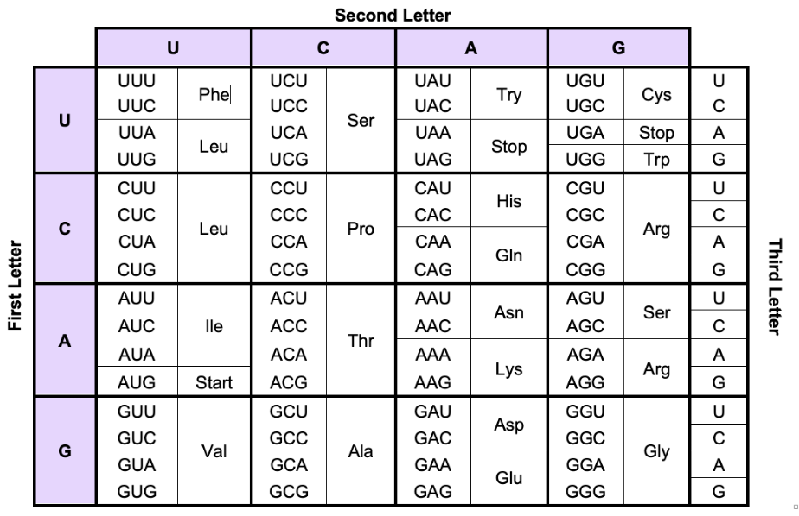

(i) Complete the table below, using the portion of herpes DNA shown, and the codon table above, to determine the sequences of RNA and amino acids that the infected cell will produce. (3 marks)

Herpes DNA (template strand) | GCT | TAC | TAG | CGA | GGC | TTA | ACT | ACC
mRNA
Amino acids

(j) From the viral DNA sequence shown, how many amino acids will the protein contain?
(1 mark)

________________________________________________________________________

Question 32 (21 marks)

Pest insects can have a devastating effect on crop production. Traditionally farmers have used pesticides that are sprayed over the crops to control many pests. These pesticides are effective against pests that eat foliage and live on the crops. The European corn borer, Ostrinia nubilalis, is a pest that has a very wide host range, attacking nearly all herbaceous plants and crops with stems large enough for the larvae to bore into. The European corn borer lays its eggs on the underside of the leaves and hatch four to nine days after being laid. The pupae bores into the stem where it feeds until it is ready to pupate. After 7 to 10 days of being in the pupae the moth hatches. The adult moth lives for 2 weeks and the cycle starts again. Farmers also have the option of using a Genetically modified pest resistant crop of Bt Corn.

- Why does the use of pesticides sprayed on crops have very little effect on the European corn borer? (2 marks)

________________________________________________________________________
________________________________________________________________________
________________________________________________________________________
________________________________________________________________________

- How does the use of Bt corn, overcome the issue of sprayed pesticides not being effective against the European corn borer? (3 marks)

________________________________________________________________________
________________________________________________________________________
________________________________________________________________________
________________________________________________________________________
________________________________________________________________________
________________________________________________________________________

- Describe the biotechnological processes used to create Bt corn. (6 marks)

________________________________________________________________________
________________________________________________________________________
________________________________________________________________________
________________________________________________________________________
________________________________________________________________________
________________________________________________________________________
________________________________________________________________________
________________________________________________________________________
________________________________________________________________________
________________________________________________________________________
________________________________________________________________________
________________________________________________________________________ ________________________________________________________________________
________________________________________________________________________
________________________________________________________________________
________________________________________________________________________
________________________________________________________________________
________________________________________________________________________
________________________________________________________________________

Tumour inducing plasmids (Ti) are found in the pathogenic bacteria, Agrobacterium tumefaciens. A simplified diagram of a Ti plasmid is shown below.
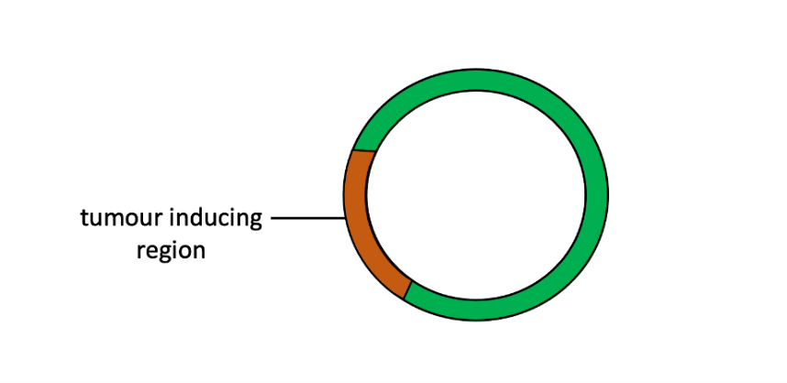

When using Ti-plasmids in plant biotechnology it first must be modified.
- Explain two reasons why the Ti plasmid must be modified when used in plant biotechnology.
(4 marks)
________________________________________________________________________
________________________________________________________________________
________________________________________________________________________
________________________________________________________________________
________________________________________________________________________
________________________________________________________________________ ________________________________________________________________________

- A neighbouring farmer has claimed that Bt corn could result in the formation of super weeds. He is very concerned about the long term implications for his farm as well as the surrounding native vegetation. Evaluate the neighbour’s claims. (6 marks)

________________________________________________________________________
________________________________________________________________________
________________________________________________________________________
________________________________________________________________________
________________________________________________________________________
________________________________________________________________________
________________________________________________________________________
________________________________________________________________________
________________________________________________________________________
________________________________________________________________________
________________________________________________________________________
________________________________________________________________________ ________________________________________________________________________
________________________________________________________________________

Question 33 (24 marks)

The flower colour of hydrangea flowers (Hydrangea macrophylla) is determined by flavonoid pigments. The absorption spectra of flavonoid pigments are pH dependent. Cellular pH of the flower determines the wavelength of light absorbed and reflected, thus the colour of the flower. The wavelengths reflected by the flower is the colour we see. Some colours we see are a mixture of reflected wavelength and how our brain process this light, for example pink. For the purpose of this investigation, scientists recorded the wavelength of 650 as pink.

Scientist determined the wavelength reflected by the flowers when planted in soils with varying pH. The scientist ran three trials of 50 plants at each pH. The scientists data is shown in table 1. Table 2 shows the colour associated with light wavelength reflection.

Table 1: Soil pH and the Wavelength of Light Reflected by Hydrangea macrophylla Flowers

Soil pH | Mean Wavelength (λ)
 | Trial 1 | Trial 2 | Trial 3 | Mean
4.5 | 438 | 470 | 490
5 | 450 | 455 | 439
5.5 | 433 | 438 | 431
6 | 420 | 429 | 426
6.5 | 404 | 427 | 393
7 | 660 | 640 | 653

(a) Construct a graph of the mean data in Table 1 on the grid below. (6 marks)
(A spare grid is available on page 38)



The visible colour reflected by the different wavelengths of light is summarised below.

Table 2: The Visible Colour Reflected by wavelengths of Light.

Light Wavelength (λ) Reflected | Colour Observed
480 - 450 | deep blue
451 - 440 | blue - purple
441 -425 | light purple
426 - 415 | purple
416 - 400 | violet
645 - 655 | pink

(b) Using the data from the investigation state the mean wavelength of light recorded that produced light purple flowers. (1 mark)

________________________________________________________________________

(c) Using the data from the investigation state the pH that produced blue – purple flowers.
(1 mark)

________________________________________________________________________

(d) Would conducting the investigation using more than 50 plants in each of the trials improve the reliability or validity of the experiment? Give two reasons for your answer. (3 marks)

________________________________________________________________________
________________________________________________________________________
________________________________________________________________________
________________________________________________________________________
________________________________________________________________________
________________________________________________________________________

Scientists have been investigating the possibility that the pH of the soil, affects gene expression and thus flower colour in hydrangeas.

(e) Describe how the environmental factor of pH could affect gene expression. (3 marks)

________________________________________________________________________
________________________________________________________________________
________________________________________________________________________
________________________________________________________________________
________________________________________________________________________
There are many examples in nature where gene products are influenced by the interaction of the gene and environmental factors.

(f) Using a named example (other than hydrangeas) describe the environmental influence on a gene and the resulting phenotype. (4 marks)

________________________________________________________________________
________________________________________________________________________
________________________________________________________________________
________________________________________________________________________
________________________________________________________________________
________________________________________________________________________
________________________________________________________________________
________________________________________________________________________

Tigers usually have an orange coat with black stripes. Some tigers have a mutation the produces a white coat with brown stripes.

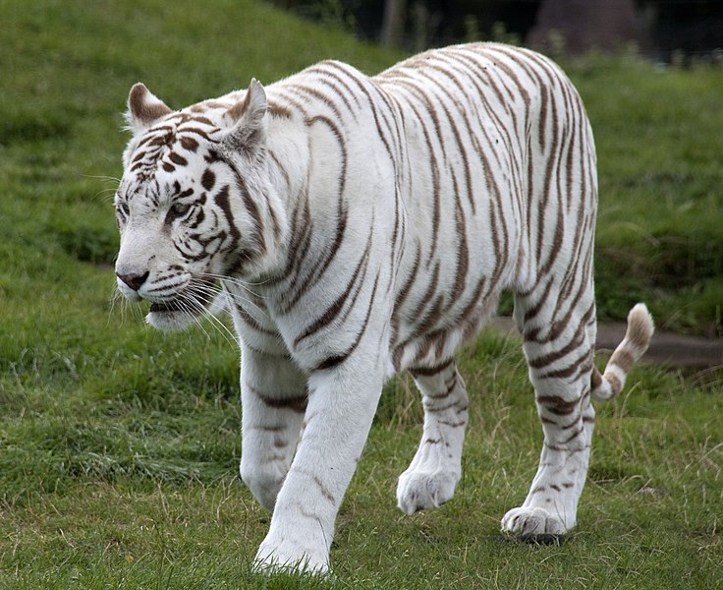

Figure 1: Tiger with mutation for coat colour.

Below is a possible DNA sequence that codes for coat colour in tigers.

Original DNA sequence

C |  | A |  | G |  | T |  | T |  | A |  | G |  | C |  | A |  | C |  | G |  | T |  | G |  | A |  | C

Mutated DNA sequence

C |  | A |  | G |  | T |  | T |  | A |  | G |  | C |  | A |  | G |  | G |  | T |  | G |  | A |  | C

(g) Categorise and name the type of mutation for white fur in tigers. (2 marks)

________________________________________________________________________
________________________________________________________________________
________________________________________________________________________
________________________________________________________________________

(h) What is the effect of the mutation on the gene? (1 mark)

________________________________________________________________________
________________________________________________________________________

(i) How can scientists use biotechnology to monitor wild populations of tigers? (3 marks)

________________________________________________________________________
________________________________________________________________________
________________________________________________________________________
________________________________________________________________________

Question 34 (17 marks)
A group of biology students were studying a population of beetles. They discovered that exoskeleton colour was determined by one gene and that two different alleles for the gene were present in the population. The population is made up of white and grey beetles. The beetles and their alleles are shown below.

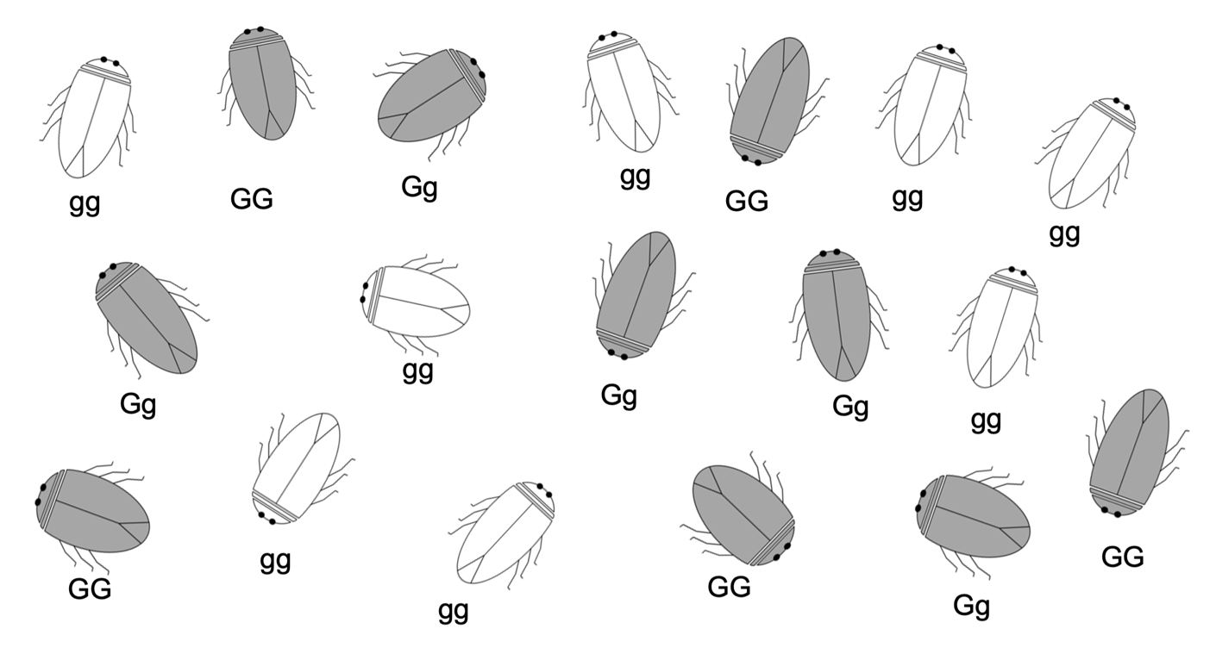

(a) Calculate the frequency, for the genotype Gg, in the beetle population. (1 mark)

________________________________________________________________________
________________________________________________________________________

(b) Calculate the allele frequencies for the beetle population. (2 marks)

________________________________________________________________________
________________________________________________________________________
________________________________________________________________________
________________________________________________________________________

Unfortunately, seven out of the eight white beetles died. The biology students wanted to increase the number of white beetles they had. They decided to mate two grey beetles in the hope that they would produce white offspring. The first mating produced all grey offspring. The students needed to determine the genotypes of the two grey beetles to see if it was possible they would have any white offspring. Unfortunately, they did not have access to any biological techniques to do this.

(c) Name a technique and explain how it could be used to determine the two grey beetle’s genotypes. (4 marks)

________________________________________________________________________
________________________________________________________________________
________________________________________________________________________
________________________________________________________________________
________________________________________________________________________
________________________________________________________________________
________________________________________________________________________
________________________________________________________________________

Upon further inspection the students found that the beetles had different types of antennae.
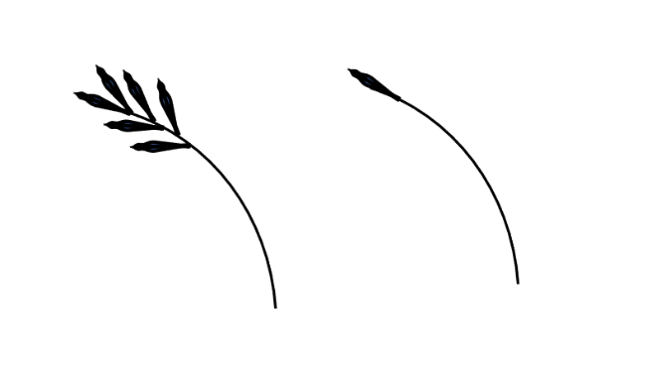

Non-feathery antennae

Feathery antennae

The mode of inheritance for having feathery antennae is sex-linked recessive. A female beetle with feathery antennae was mated with a male beetle with non-feathery antennae. The mating’s were continued and the pedigree below shows the inheritance of feathery antennae.

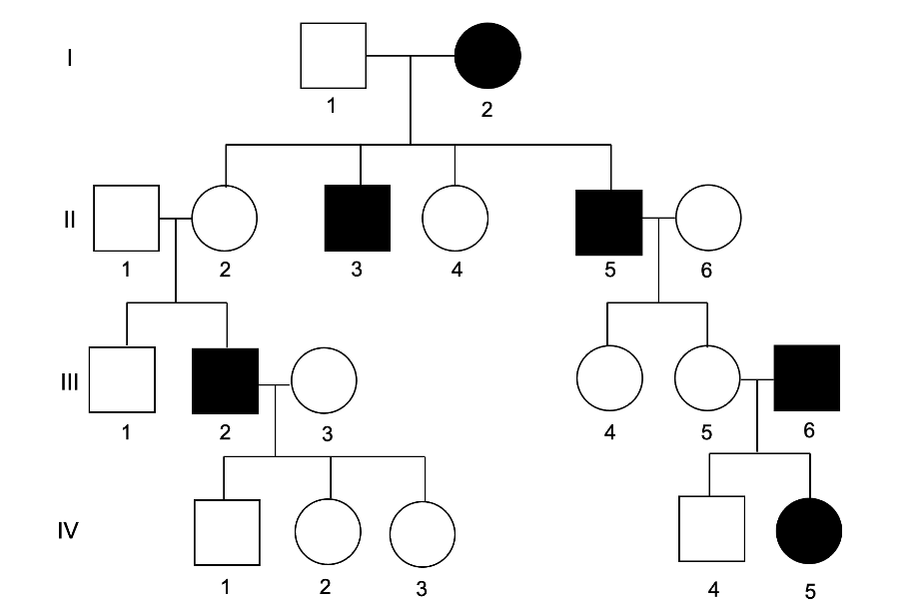

(d) State the phenotype for the following individuals (2 marks)

(i) (I, 2). ______________________________________________________________

- (III, 4). ______________________________________________________________

(e) State the genotype for the following individuals (2 marks)

- (II, 3). _______________________________________________________________

- (III, 4). _______________________________________________________________

(f) If individual (II,5) was mated with individual (III, 3) what is the probability of having an offspring with feathery antennae? Show all working. (6 marks)

________________________________________________________________________
________________________________________________________________________
________________________________________________________________________
________________________________________________________________________
________________________________________________________________________
________________________________________________________________________
________________________________________________________________________
________________________________________________________________________
________________________________________________________________________
________________________________________________________________________
________________________________________________________________________
Question 35 (17 marks)
Binary fission and mitosis are both forms of cell division.

- What type of organisms replicate using binary fission? (1 mark)

________________________________________________________________________

(b) Describe the process of binary fission. (5 marks)

________________________________________________________________________
________________________________________________________________________
________________________________________________________________________
________________________________________________________________________
________________________________________________________________________
________________________________________________________________________
________________________________________________________________________
________________________________________________________________________
________________________________________________________________________
________________________________________________________________________

To produce offspring a female snake needs to mate with a male snake and fertilisation must occur.

(c) What type of cell reproduction does this require? (1 mark)

________________________________________________________________________

(d) Explain the role of fertilisation in the reproduction of snakes and other sexually reproducing animals. (4 marks)

________________________________________________________________________
________________________________________________________________________
________________________________________________________________________
________________________________________________________________________
________________________________________________________________________
________________________________________________________________________
________________________________________________________________________
(e) The phylogenetic tree below shows the evolution of certain vertebrate groups.

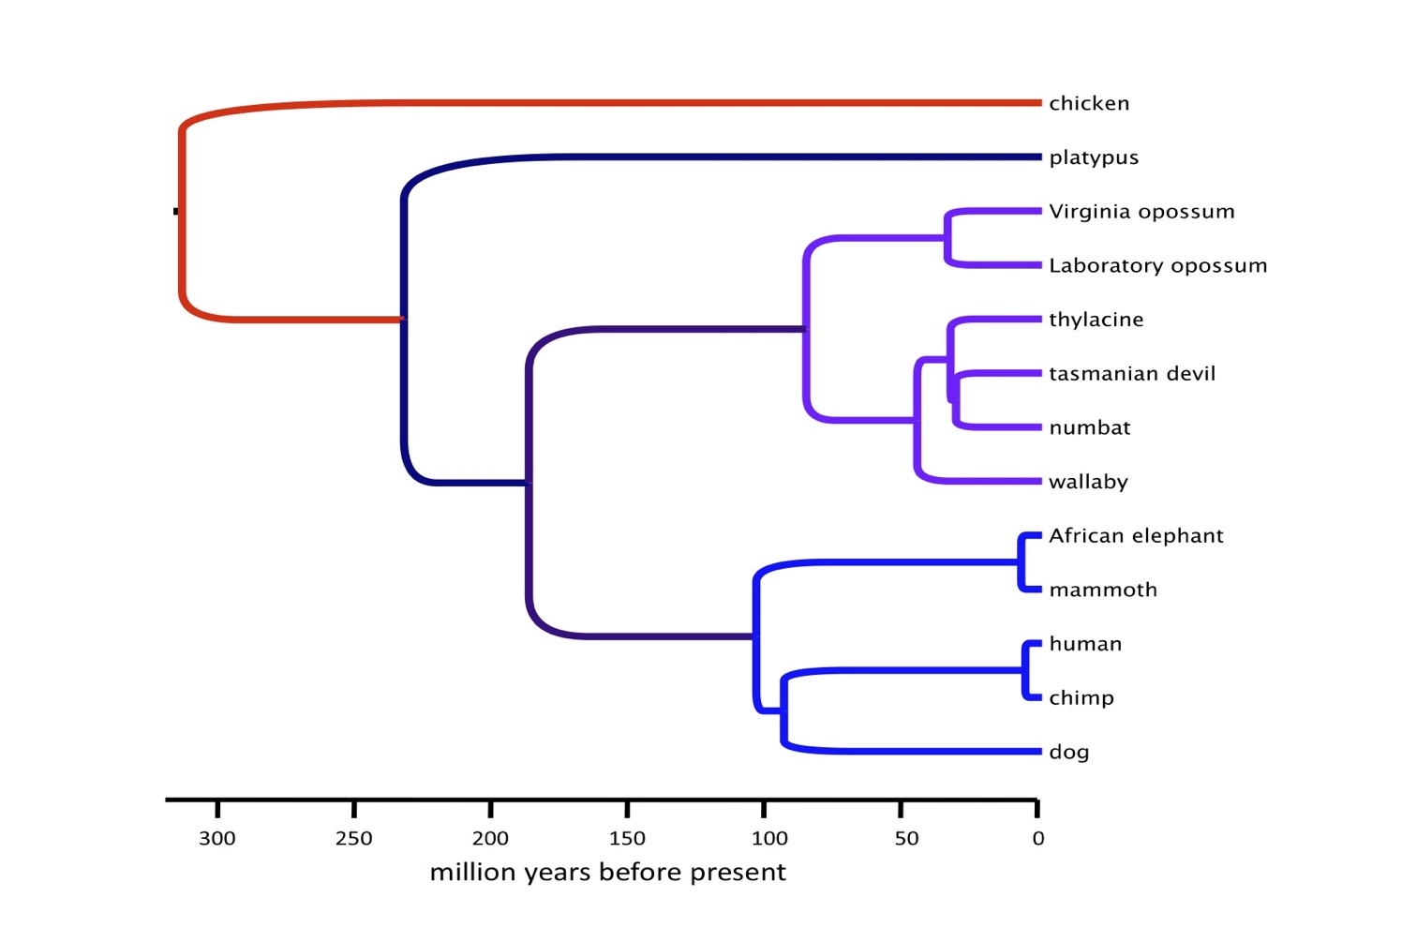

(i) Which animal is most closely related to the Tasmanian devil and Numbat? (1 mark)

________________________________________________________________________

(ii) When did the common ancestor of the platypus and other mammals exists? (1 mark)

_______________________________________________________________________

(iii) List four(4) types of evidence that scientists may have used to create this phylogenetic tree. (4 marks)

_______________________________________________________________________

________________________________________________________________________

________________________________________________________________________

________________________________________________________________________

End of Section Two

Section Three: Extended answer 20% (40 marks)

Section Three consists of four questions.

Questions 36 and 37 form Part A. Questions 38 and 39 form Part B. Answer one question from Part A and one question from Part B.

Use black or blue pen for this section. Do not use erasable or gel pens. Only graphs and diagrams may be drawn in pencil. Responses can include; labelled diagrams with explanatory notes; lists of points with linking sentences; labelled tables and/or graphs; and/or annotated flow diagrams with introductory notes.

Supplementary pages for planning/continuing your answers to questions are provided at the end of this Question/Answer booklet. If you use these pages to continue an answer, indicate at the original answer where the answer is continued, i.e. give the page number.

Suggested working time: 50 minutes

Part A

Choose either Question 36 or Question 37.

Indicate the question you will answer by ticking the box next to the question. Write your answer on pages 31 - 35. When you have answered your first question, turn to page 36 and indicate on that page the second question you will answer.

Question 36 (20 marks)

(a) Compare artificial selection and natural selection. (10 marks)

(b) Explain why the fossil record is incomplete and how fossils provide evidence for evolution.
(10 marks)

Question 37 (20 marks)

(a) Compare transcription and DNA replication. (10 marks)

The New Zealand sea lion population declined significantly in the 1900s due to sealing. Seal lions were killed on mass for their fur skins. Boats from Europe brought “gangs” of seal hunters to New Zealand to collect the furs. Most boats would leave with a minimum of 10 000 seal furs. They were sold across the globe.

(b) Explain the effect of the significant decline in sea lion population on the viability of the sea lion gene pool and survival of the species. (10 marks)

Question number: ______________
______________________________________________________________________________
______________________________________________________________________________
______________________________________________________________________________
______________________________________________________________________________
______________________________________________________________________________
______________________________________________________________________________
______________________________________________________________________________
______________________________________________________________________________
______________________________________________________________________________
______________________________________________________________________________
______________________________________________________________________________
______________________________________________________________________________
______________________________________________________________________________
______________________________________________________________________________
______________________________________________________________________________
______________________________________________________________________________
______________________________________________________________________________
______________________________________________________________________________
______________________________________________________________________________
______________________________________________________________________________
______________________________________________________________________________
______________________________________________________________________________
______________________________________________________________________________
______________________________________________________________________________
______________________________________________________________________________
______________________________________________________________________________
______________________________________________________________________________
Question number: ______________
______________________________________________________________________________
______________________________________________________________________________
______________________________________________________________________________
______________________________________________________________________________
______________________________________________________________________________
______________________________________________________________________________
______________________________________________________________________________
______________________________________________________________________________
______________________________________________________________________________
______________________________________________________________________________
______________________________________________________________________________
______________________________________________________________________________
______________________________________________________________________________
______________________________________________________________________________
______________________________________________________________________________
______________________________________________________________________________
______________________________________________________________________________
______________________________________________________________________________
______________________________________________________________________________
______________________________________________________________________________
______________________________________________________________________________
______________________________________________________________________________
______________________________________________________________________________
______________________________________________________________________________
______________________________________________________________________________
______________________________________________________________________________
______________________________________________________________________________
Question number: ______________
______________________________________________________________________________
______________________________________________________________________________
______________________________________________________________________________
______________________________________________________________________________
______________________________________________________________________________
______________________________________________________________________________
______________________________________________________________________________
______________________________________________________________________________
______________________________________________________________________________
______________________________________________________________________________
______________________________________________________________________________
______________________________________________________________________________
______________________________________________________________________________
______________________________________________________________________________
______________________________________________________________________________
______________________________________________________________________________
______________________________________________________________________________
______________________________________________________________________________
______________________________________________________________________________
______________________________________________________________________________
______________________________________________________________________________
______________________________________________________________________________
______________________________________________________________________________
______________________________________________________________________________
______________________________________________________________________________
______________________________________________________________________________
______________________________________________________________________________
Question number: ______________
______________________________________________________________________________
______________________________________________________________________________
______________________________________________________________________________
______________________________________________________________________________
______________________________________________________________________________
______________________________________________________________________________
______________________________________________________________________________
______________________________________________________________________________
______________________________________________________________________________
______________________________________________________________________________
______________________________________________________________________________
______________________________________________________________________________
______________________________________________________________________________
______________________________________________________________________________
______________________________________________________________________________
______________________________________________________________________________
______________________________________________________________________________
______________________________________________________________________________
______________________________________________________________________________
______________________________________________________________________________
______________________________________________________________________________
______________________________________________________________________________
______________________________________________________________________________
______________________________________________________________________________
______________________________________________________________________________
______________________________________________________________________________
______________________________________________________________________________
Question number: ______________
______________________________________________________________________________
______________________________________________________________________________
______________________________________________________________________________
______________________________________________________________________________
______________________________________________________________________________
______________________________________________________________________________
______________________________________________________________________________
______________________________________________________________________________
______________________________________________________________________________
______________________________________________________________________________
______________________________________________________________________________
______________________________________________________________________________
______________________________________________________________________________
______________________________________________________________________________
______________________________________________________________________________
______________________________________________________________________________
______________________________________________________________________________
______________________________________________________________________________
______________________________________________________________________________
______________________________________________________________________________
______________________________________________________________________________
______________________________________________________________________________
______________________________________________________________________________
______________________________________________________________________________
______________________________________________________________________________
______________________________________________________________________________
______________________________________________________________________________
Part B

Choose either Question 38 or Question 39.

Indicate the question you will answer by ticking the box next to the question. Write your answer on the pages provided.

Question 38 (20 marks)

(a) Explain how geographical isolation and microevolutionary changes can result in speciation. (10 marks)

(b) Explain the process of sequencing DNA using Sanger sequencing. (10 marks)

Question 39 (20 marks)

(a) Explain how homologous structures (divergent evolutions, analogous structures (convergent evolution) and vestigial structures provide evidence for the theory of evolution. (10 marks)

(b) Explain how crossing over and independent assortment during meiosis can result in increased genetic diversity. (10 marks)

End of questions

Question number: ______________
______________________________________________________________________________
______________________________________________________________________________
______________________________________________________________________________
______________________________________________________________________________
______________________________________________________________________________
______________________________________________________________________________
______________________________________________________________________________
______________________________________________________________________________
______________________________________________________________________________
______________________________________________________________________________
______________________________________________________________________________
______________________________________________________________________________
______________________________________________________________________________
______________________________________________________________________________
______________________________________________________________________________
______________________________________________________________________________
______________________________________________________________________________
______________________________________________________________________________
______________________________________________________________________________
______________________________________________________________________________
______________________________________________________________________________
______________________________________________________________________________
______________________________________________________________________________
______________________________________________________________________________
______________________________________________________________________________
______________________________________________________________________________
______________________________________________________________________________
Question number: ______________
______________________________________________________________________________
______________________________________________________________________________
______________________________________________________________________________
______________________________________________________________________________
______________________________________________________________________________
______________________________________________________________________________
______________________________________________________________________________
______________________________________________________________________________
______________________________________________________________________________
______________________________________________________________________________
______________________________________________________________________________
______________________________________________________________________________
______________________________________________________________________________
______________________________________________________________________________
______________________________________________________________________________
______________________________________________________________________________
______________________________________________________________________________
______________________________________________________________________________
______________________________________________________________________________
______________________________________________________________________________
______________________________________________________________________________
______________________________________________________________________________
______________________________________________________________________________
______________________________________________________________________________
______________________________________________________________________________
______________________________________________________________________________
______________________________________________________________________________
Question number: ______________
______________________________________________________________________________
______________________________________________________________________________
______________________________________________________________________________
______________________________________________________________________________
______________________________________________________________________________
______________________________________________________________________________
______________________________________________________________________________
______________________________________________________________________________
______________________________________________________________________________
______________________________________________________________________________
______________________________________________________________________________
______________________________________________________________________________
______________________________________________________________________________
______________________________________________________________________________
______________________________________________________________________________
______________________________________________________________________________
______________________________________________________________________________
______________________________________________________________________________
______________________________________________________________________________
______________________________________________________________________________
______________________________________________________________________________
______________________________________________________________________________
______________________________________________________________________________
______________________________________________________________________________
______________________________________________________________________________
______________________________________________________________________________
______________________________________________________________________________
Question number: ______________
______________________________________________________________________________
______________________________________________________________________________
______________________________________________________________________________
______________________________________________________________________________
______________________________________________________________________________
______________________________________________________________________________
______________________________________________________________________________
______________________________________________________________________________
______________________________________________________________________________
______________________________________________________________________________
______________________________________________________________________________
______________________________________________________________________________
______________________________________________________________________________
______________________________________________________________________________
______________________________________________________________________________
______________________________________________________________________________
______________________________________________________________________________
______________________________________________________________________________
______________________________________________________________________________
______________________________________________________________________________
______________________________________________________________________________
______________________________________________________________________________
______________________________________________________________________________
______________________________________________________________________________
______________________________________________________________________________
______________________________________________________________________________
______________________________________________________________________________
Question number: ______________
______________________________________________________________________________
______________________________________________________________________________
______________________________________________________________________________
______________________________________________________________________________
______________________________________________________________________________
______________________________________________________________________________
______________________________________________________________________________
______________________________________________________________________________
______________________________________________________________________________
______________________________________________________________________________
______________________________________________________________________________
______________________________________________________________________________
______________________________________________________________________________
______________________________________________________________________________
______________________________________________________________________________
______________________________________________________________________________
______________________________________________________________________________
______________________________________________________________________________
______________________________________________________________________________
______________________________________________________________________________
______________________________________________________________________________
______________________________________________________________________________
______________________________________________________________________________
______________________________________________________________________________
______________________________________________________________________________
______________________________________________________________________________
______________________________________________________________________________
Supplementary Page
Question number: ______________
______________________________________________________________________________
______________________________________________________________________________
______________________________________________________________________________
______________________________________________________________________________
______________________________________________________________________________
______________________________________________________________________________
______________________________________________________________________________
______________________________________________________________________________
______________________________________________________________________________
______________________________________________________________________________
______________________________________________________________________________
______________________________________________________________________________
______________________________________________________________________________
______________________________________________________________________________
______________________________________________________________________________
______________________________________________________________________________
______________________________________________________________________________
______________________________________________________________________________
______________________________________________________________________________
______________________________________________________________________________
______________________________________________________________________________
______________________________________________________________________________
______________________________________________________________________________
______________________________________________________________________________
______________________________________________________________________________
______________________________________________________________________________

Supplementary Page
Question number: ______________
______________________________________________________________________________
______________________________________________________________________________
______________________________________________________________________________
______________________________________________________________________________
______________________________________________________________________________
______________________________________________________________________________
______________________________________________________________________________
______________________________________________________________________________
______________________________________________________________________________
______________________________________________________________________________
______________________________________________________________________________
______________________________________________________________________________
______________________________________________________________________________
______________________________________________________________________________
______________________________________________________________________________
______________________________________________________________________________
______________________________________________________________________________
______________________________________________________________________________
______________________________________________________________________________
______________________________________________________________________________
______________________________________________________________________________
______________________________________________________________________________
______________________________________________________________________________
______________________________________________________________________________
______________________________________________________________________________
______________________________________________________________________________
______________________________________________________________________________
Supplementary Page
Question number: ______________
______________________________________________________________________________
______________________________________________________________________________
______________________________________________________________________________
______________________________________________________________________________
______________________________________________________________________________
______________________________________________________________________________
______________________________________________________________________________
______________________________________________________________________________
______________________________________________________________________________
______________________________________________________________________________
______________________________________________________________________________
______________________________________________________________________________
______________________________________________________________________________
______________________________________________________________________________
______________________________________________________________________________
______________________________________________________________________________
______________________________________________________________________________
______________________________________________________________________________
______________________________________________________________________________
______________________________________________________________________________
______________________________________________________________________________
______________________________________________________________________________
______________________________________________________________________________
______________________________________________________________________________
______________________________________________________________________________
______________________________________________________________________________

Supplementary Page
Question number: ______________
______________________________________________________________________________
______________________________________________________________________________
______________________________________________________________________________
______________________________________________________________________________
______________________________________________________________________________
______________________________________________________________________________
______________________________________________________________________________
______________________________________________________________________________
______________________________________________________________________________
______________________________________________________________________________
______________________________________________________________________________
______________________________________________________________________________
______________________________________________________________________________
______________________________________________________________________________
______________________________________________________________________________
______________________________________________________________________________
______________________________________________________________________________
______________________________________________________________________________
______________________________________________________________________________
______________________________________________________________________________
______________________________________________________________________________
______________________________________________________________________________
______________________________________________________________________________
______________________________________________________________________________
______________________________________________________________________________
______________________________________________________________________________
______________________________________________________________________________
Supplementary Page
Question number: ______________
______________________________________________________________________________
______________________________________________________________________________
______________________________________________________________________________
______________________________________________________________________________
______________________________________________________________________________
______________________________________________________________________________
______________________________________________________________________________
______________________________________________________________________________
______________________________________________________________________________
______________________________________________________________________________
______________________________________________________________________________
______________________________________________________________________________
______________________________________________________________________________
______________________________________________________________________________
______________________________________________________________________________
______________________________________________________________________________
______________________________________________________________________________
______________________________________________________________________________
______________________________________________________________________________
______________________________________________________________________________
______________________________________________________________________________
______________________________________________________________________________
______________________________________________________________________________
______________________________________________________________________________
______________________________________________________________________________
______________________________________________________________________________

Supplementary Page
Question number: ______________
______________________________________________________________________________
______________________________________________________________________________
______________________________________________________________________________
______________________________________________________________________________
______________________________________________________________________________
______________________________________________________________________________
______________________________________________________________________________
______________________________________________________________________________
______________________________________________________________________________
______________________________________________________________________________
______________________________________________________________________________
______________________________________________________________________________
______________________________________________________________________________
______________________________________________________________________________
______________________________________________________________________________
______________________________________________________________________________
______________________________________________________________________________
______________________________________________________________________________
______________________________________________________________________________
______________________________________________________________________________
______________________________________________________________________________
______________________________________________________________________________
______________________________________________________________________________
______________________________________________________________________________
______________________________________________________________________________
______________________________________________________________________________
______________________________________________________________________________
Spare grid



ACKNOWLEDGEMENTS

Questions 32
Tiger image
https://upload.wikimedia.org/wikipedia/commons/3/3a/White_Tiger_6_%283865790598%29.jpg

